MATH 3210 Practice Final Exam

You now have weekly quizzes to study.
1. (a) Use truth tables to determine whether the following is a tautology:
(¬ p ∧ (p → q)) ⇒ (¬q).
(b) Is the converse of the above statement a tautology? Proof?

2. (a) Write the contrapositive of the statement: If x² = 1 then x = 1 or x = -1.
(b) Let A, B, and C be any three sets and consider the sentence:
If A ∩ B = A ∩ C then B = C. Prove that this statement is false.
(c) Write the converse of the statement in part (a). Is the converse true? Proof?
(d) Express the statement in part a and its converse in “iff” format.

3.

- If A = {1, 2, 3} and B = {a, b, c, d}. How many 1 – 1 functions are there from
- A to B? Explain. How many functions are there from A to B? Explain.
How many onto functions are there from A to B? Explain.
(d) Is the function g: Z  Z defined by g(n) = 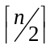 a one to one function? Is g an onto function? Explain.
(e) Is the function f: R Z defined by f(n) = a one to one function? Is f an onto function? Explain.

5. (a) Suppose that a department contains 4 men and 6 women.
How many ways are there to form a committee with 7 members? Explain, and do all computations without the use of a calculator.
- How many ways are there to form a committee with 7 members if two of the members of the department refuse to serve on the committee with each other. Explain.
- How many ways are there to form a committee with 7 members if two of the committee members will not serve on the committee unless they are on the committee together. Explain.
- How many ways are there to form a committee with 7 members if the committee must have more women than men? Explain.

6. Expand and simplify. 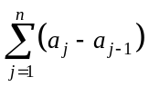
7. Use mathematical induction to prove:
(1 - )(1 - )(1 - ) . . . (1 - 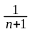) = 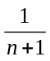 for every positive integer n.

8. Let A = {a, b, c} , and let R be the relation defined on A defined by the following matrix:
M_{R} = 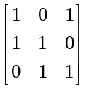
(a) Describe R by listing the ordered pairs in R and draw the digraph of this relation.
(b) Which of the properties: reflexive, antisymmetric and transitive are true for the given relation? Begin your discussion by defining each term in general first and then how the definition relates to this specific example.
(c) Is this relation a partial order? Explain. If this relation a partial order, draw its Hasse diagram.
(d) Define transitive closure and the find the transitive closure of this relation R.

- (a) Let x be a integer. State the “proof by contradiction” method of proof and then use it to prove: If x² + 2x + 1 is an even integer then x is an odd integer. Explain completely.

(b) Prove the following about integers: x is an odd integer iff x² + 2x + 1 is an even integer. Explain completely.

10. Consider the relation S = {(1, 2), (2, 3), (3, 4),(2, 1)} on the set
A = {1, 2, 3, 4}.
(a) Find the boolean (yes/no) matrix for this relation.
(b) Use Warshall’s Algorithm to compute the transitive closure of the relation S.
(c) Explain briefly what the transitive closure of the relation S means.
(d) Draw the digraph of the transitive closure of the relation S and determine whether this graph is connected.
11. Let x and y be any real numbers.
(a) Express the following in English and then determine if it is true. Explain fully.
∃_{x} ∀_{y} x + y = 0.
(b) Express the following in English and then determine if it is true. Explain fully.
∀_{y} ∃_{x} x + y = 0.
12. Assume A, B and C are n x n matrices whose entries are real numbers. That is, they are known “contants”. Assume that A is invertible. Also assume X is a “variable” matrix. Solve the following for X: (a) XA + B = C (b) AX + B = X (c) XA + C = X
13. Let A and B be nxn matrices . Is A² - B² = (A + B) (A - B)? Proof?
14. Let D = days of the week {M, T, W, R, F},
E = {Brian (B), Jim (J), Karen (K)} be the employees of a tutoring center at a University and let
U = {Courses the tutoring center needs tutors for}
= {Calculus I (I), Calculus II (II), Calculus III (III), Computers I (C₁), Computers II (C₂), Precalculus (P)}.
We define the relation R from D into E by d R e if employee e is scheduled to work on day d. We also define S from E into U by e r u if employee e is capable of tutoring students in course u. If

M_{R} =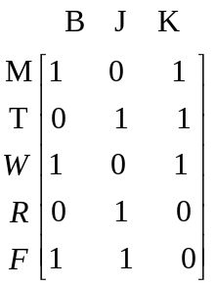 and M_{S} = 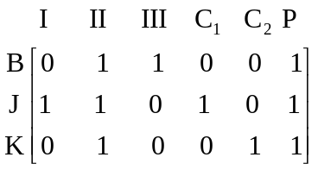

- Interpret the above matrices.
- Determine which courses will have tutors available on which days.
- How many tutors are available for tutoring each course on each day?

Another example
. Let A = { a, b, c, d } , and let r be the relation defined on A whose yes/no or Boolean matrix is

M_{r} =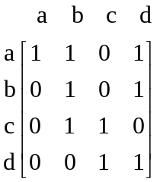.
- (5 points) Draw the digraph of the relation represented by this Boolean matrix.

(b) (20 points) Assume the Boolean matrix above is M_{r} and that M_{r} represents the relation r where r represents the connecting flights that an airline has between 4 cities: a, b, c, and d. So there is a 1 in row x column y iff there is a connecting flight from city x to city y. Assume that the 1’s on the main diagonal indicate that the planes remain at that airport. That is, the rows of the matrix represent the cities of the origins of the flight and the columns represent the destination cities. Let a stand for the airport in the city of Manchester, let b stand for the airport in Boston, c stand for the Chicago airport, and d for the airport in the city of Denver.
  - Compute and interpret the Boolean product M_{r} ². Use the digraph in part (a) in your explanation. (Remember to use Boolean arithmetic)

M_{r} ² =

Interpretation of M_{r} ². Use the digraph in part (a) in your explanation.

  - Now call the given matrix A.
Compute and interpret the product A² using regular not Boolean arithmetic .

A ² =

Interpretation of A ². Use the digraph in part (a) in your explanation.

